A000-Costa Rica-Guanacasta-Nicoya-Axe Deity-Jadeite-200 BCE-200 CE

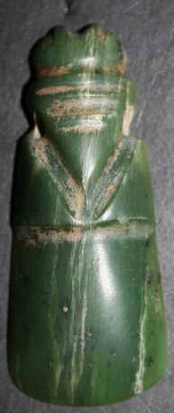 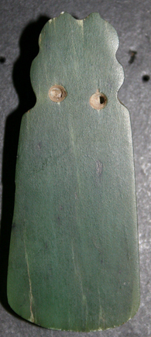

**Case no.:** 14

**Formal Label:** Costa Rica, Guanacasta-Nicoya Culture, Axe Deity of Jadeite

**Accession Number:**

Display Description:

This jade axe deity amulet was believed to have an inhering spirit that could answer specific requests of the wearer. The earliest known worked jade in Costa Rica (in the form of an axe deity) was discovered at the site of La Regla on the Gulf of Nicoya. One of the most typical forms of Pre-Columbian Costa Rican lapidary work is the so-called axe-god, in which an animal, human being or a composite effigy surmounts a celt-like polished blade. Common in the Costa Rican lapidary corpus are axe-gods with at first glance appear to be avian effigies. They are in fact part of a zoo-anthropomorphic continuum, with many jades having relative degrees of "birdness" and "humanness." Outstanding among Costa Rican jades is the form long known in that country as the  dios-hacha, or axe deity. The term encompasses conveniently all the stylized figure pendants shaped as though they had been made from axes of petaloid celts. Costa Rican jadeite and greenstone artifacts can be divided into five basic categories: whole celt, half celt, quarter celt, and a general category of other forms. Most of the jade artifacts are pendants which appear to have been produced from raw material in the form of a celt. The most impressive jade pendant (found on the Lama Corral 3 site in Costa Rica) was a virtually three-dimensional quetzal (bird found in Mexico to Panama) effigy axe god. In Costa Rica, all artifacts made from green stone have traditionally been classified as jade.

**LC Classification**: [F1545.3.P6](http://luna.wellesley.edu/search%7ES1?/mF1545.3.P6+C67+1988/mf++1545.3+p6+c67+1988/-3,-1,,B/browse)

**Date or Time Horizon:** 200 BCE-200 CE

**Geographical Area:** Source of the jadeite: Motagua river valley in Guatemala

**Cultural Affiliation:** Costa Rican region of Guanacaste-Nicoya culture

**Medium:** Jadeite

**Dimensions:**

**Weight:**

**Provenance:** burial context of Costa Rican region of Guanacaste-Nicoya culture; then old Guatemalan family heirloom.

**Condition:** Excellent with mineral encrustations in the suspension holes and bow string grooves indicating its context was an earthly internment with the deceased.

**Discussion:** Source of this jadeite: ancient Guatemala, Motagua river valley. Cultural attribution: Costa Rican region of Guanacaste-Nicoya culture, circa 200 BCE-200 CE. A strikingly beautiful and expertly suspension bow-string carved deep, apple-green jadeite of the avian axe deity depicted with two rounded tufts on top, abstract facial features and a wide beak done with a suspension bow string, two drilled perforations through the neck for suspension.

“Jadeite” signifies a sodium and aluminum silicate and is a hard and highly translucent stone whose color ranges from blue-green, to apple-green. The only known prehistoric source of jadeite in Mesoamerica is the Motagua River valley in Guatemala. Prehistoric peoples of the of the Guanacaste-Nicoya culture used this source alone in the trade and exchange of this valuable élite stone. Jadeite’s cultural significance is its green color, the color of life, which was associated with both water and vegetation (especially young maturing maize leaves). Olmec, Maya, Aztec and Costa Rican élites particularly appreciated jadeite carvings and artifacts and commissioned elegant pieces from skillful artisans. Jadeite was traded and exchanged among élite members as a luxury item all over the Mesoamerican world. It was replaced by gold very late in time in Mesoamerica ca 500 AD/CE in Costa Rica and Lower Central America. In these locations, frequent contacts with South America made gold more easily available.

Jadeite artifacts are often found in élite burial contexts, as personal amulets suspended around the neck as this example shows. Sometimes a jadeite bead was placed within the mouth of the deceased. Jadeite objects are also found in dedicatory offerings for the construction or the ritual termination of public buildings, as well as in more private residential contexts. Unfortunately, jade artifacts are hard to date, even if found in a relatively clear chronological context, since this particularly precious and hard-to-find stone was often passed down from one generation to another as heirlooms. Finally, because of their value, jade objects are often looted from archaeological sites and sold to private collectors. For this reason, a huge number of published items are from an unknown provenance and are missing an important piece of information. We are lucky to have this information for this piece.

**References:**

Lange, Frederick W., 1993, Pre-Columbian Jade: New Geological and Cultural Interpretations. University of Utah Press.

Seitz, R., G.E. Harlow, V.B. Sisson, and K.A. Taube, 2001, Olmec Blue and Formative Jade Sources: New Discoveries in Guatemala, Antiquity, 75: 687-688